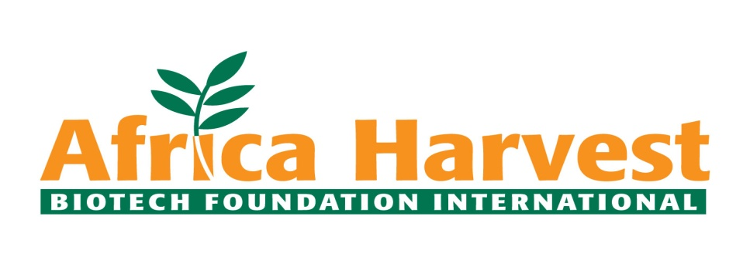

**Africa Harvest Biotech Foundation International (AHBFI)**

Washington DC ◆ Nairobi ◆ Johannesburg ◆Toronto ◆Kinshasa

**Expression of Interest (EoI)**

**Provision of Capacity Building, Mentorship, and Market Linkages for the MARKUP II Agribusiness Accelerator (Kenya)**

**Ref No.:  
Issue Date: 03/09/2025**

**1. Background**

**1.1 About MARKUP II**

The Market Access Upgrade Programme (MARKUP II) is a regional development initiative funded by the European Union (EU) and implemented by the International Trade Centre (ITC), in partnership with national and regional institutions. The programme runs from 2023–2027 across six East African Community (EAC) partner states: Burundi, Kenya, Rwanda, South Sudan, Tanzania, and Uganda. The overall goal of MARKUP II is to contribute to economic development in the EAC through enhanced sustainable intra-African and EU-Africa trade. This will be achieved by improving livelihoods, employment, and export competitiveness for MSMEs through support to selected value chains with high potential for value addition and export growth.

**1.2 The MARKUP II Agribusiness Accelerator in Kenya**

In Kenya, MARKUP II is supporting a youth-focused Agribusiness Accelerator targeting 30 youth-led businesses (18–35 years) operating within the coffee, packaging, and leather value chains. The Accelerator aims to strengthen participants’ business, technical, and market readiness skills while linking them to networks and opportunities that enable growth, investment readiness, and access to regional and international markets.

**2. Scope of Services Requested**

Africa Harvest, with support from ITC, seeks to engage a qualified partner (organization, consortium, or institution) to collaborate in the design and delivery of the MARKUP II Agribusiness Accelerator. The selected partner will be expected to:

**2.1 Capacity Building**

* Support in delivering training modules tailored to the needs of youth-led SMEs in the target value chains, covering technical agribusiness skills, entrepreneurship, and investment readiness.
* Facilitate reflective and practical learning sessions to reinforce knowledge and encourage peer-to-peer learning.

**2.2 Mentorship & Coaching**

* Provide one-on-one and group mentorship opportunities with experienced industry leaders.
* Equip agripreneurs with practical strategies to apply knowledge gained in the Accelerator to strengthen their businesses and prepare for financing and markets.

**2.3 Market Access & Ecosystem Linkages**

* Map and identify relevant B2B opportunities, exhibitions, and networking events within Kenya.
* Facilitate access for cohort members to at least four such opportunities during the Accelerator.
* Leverage networks to foster partnerships, investment linkages, and market opportunities for the 30 youth-led businesses.

**2.4 Convenings & Showcasing**

* Facilitate regular cohort meetups and expert-led sessions to encourage collaboration, experience-sharing, and ecosystem engagement.
* Support in organizing an end-of-cohort Showcase Event to highlight agripreneur innovations and achievements to potential buyers, investors, and stakeholders.

**3. Expected Results**

By the end of the engagement, the partner is expected to deliver:

1. Successful recruitment, onboarding, and retention of at least 30 youth-led agribusinesses.
2. Completion of the agreed training modules by at least 90% of participants.
3. Evidence of improved agribusiness knowledge and market readiness among at least 80% of participants.
4. Participation of agripreneurs in at least four B2B or market linkage opportunities.
5. A successful final showcase event featuring all cohort participants.

**4. Eligibility Criteria**

Applicants should be:

1. Legally registered organizations in Kenya, with evidence of compliance with relevant national laws. Organizations that have a presence in Africa will be preferred.
2. Experienced in entrepreneurship support, youth agribusiness, capacity building, mentorship, or market linkage facilitation. A track record of supporting youth in business will be preferred in addition to having a strong ecosystem/network of entrepreneurs to support and mentor youth in growing their enterprises.
3. Preferably with experience working with donor-funded programmes, and youth- or SME-focused interventions.
4. Able to demonstrate:

* Proven track record of delivering similar programmes especially those with tailormade mentorship and B2B linkages.
* Financial and technical capacity to implement the outlined activities.
* Strong networks within agribusiness, investment, and market ecosystems in Kenya and the EAC.
* Experience in policy and eco-system engagement.

1. Any prior engagement/collaborations with ITC and participation in Ye! Community engagements will be an advantage.

**5. Period of Performance**

The assignment will run from September 2025 to January 2026, aligned with the MARKUP II Accelerator activity schedule.

**6. Submission Requirements**

Interested organizations are invited to submit an Expression of Interest (EoI) that includes:

1. Organizational profile, registration documents, and track record in similar assignments.
2. Technical proposal outlining approach, methodology, and how the applicant will deliver on the scope of services.
3. Profiles/CVs of proposed key team members.
4. Brief budget indicative of expected costs (note: final costs to be on agreed during contracting).
5. Most recent audited financial statements (if available).

**7. Evaluation Criteria**

EOIs will be assessed against the following criteria:

1. Organizational capacity & governance (30%) - Evidence of sound systems, management, and relevant experience.
2. Experience (30%) - Track record in similar assignments, including examples of past work.
3. Technical approach (40%) - Clear and innovative methodology, demonstration of understanding of the youth agribusiness ecosystem, and ability to deliver within timelines.

**8. Submission Deadline**

Interested applicants should submit their EoIs electronically to [procurement@africaharvest.org](mailto:procurement@africaharvest.org) not later than 9th September 2025 at 11:59pm EAT.