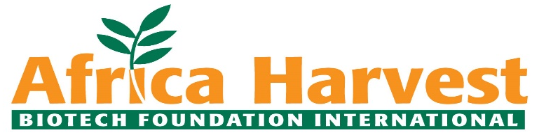

Vacancy Announcement: County Project Officers-Restore Africa Program- Kenya (RAP-K).

About our organization:
Africa Harvest Biotech Foundation International is a Non-Governmental International Organization with Headquartered in Nairobi Kenya and working with rural communities across Kenya & Africa to address challenges of food, nutrition, and income insecurity by streamlining agricultural value chains. The organization implements programs in Cereals, Horticulture, tubers, legumes, poultry, and Dairy goats value chains with the aim of enhancing production and productivity, catalyzing the development of SMEs and generating dignified and fulfilling jobs for Youth and Women. Our programs are designed to enhance resource utilization, empower livelihoods, enhance ecosystem management, and contribute to Sustainable Development Goals (SDGs) through the social, environmental, and economic pillars.

About the position:
The County Project Officers will be responsible for ensuring the timely implementation of field activities as per the project workplan and implementation schedules. The referenced project seeks support communities in Kwale County to achieve the goal of sustained improvement in eco-system restoration, livelihoods, and resilience to climate change for 69,834 smallholder farmers and pastoralists (men, women and youth).

Successful candidates will report to the Project Manager.

Duties and Responsibilities
These include:
- Conduct farmer contact meetings and follow up
- Facilitate recruitment and selection of lead farmers.
- Assess training needs of the farmers and various stakeholders and discuss the needs with project officer and management on a regular basis.
- Enhance linkages and connection to input suppliers, stakeholders and markets
- Perform desk review of the existing and potential Climate Smart Agriculture (CSA) and Agro-ecological practices that support transitions to sustainable agriculture.
- Conduct gender responsive CSA trainings.
- Analyze needs and adoption barriers for Agro-ecology and CSA approaches among farmers, producer organizations, and agribusinesses.
- Ensure that cross-cutting aspects such as nutrition, gender equity, social inclusion, and water systems are included and well-integrated into CSA.
- Assist in developing training and workshop content for farmers, government partners, small and medium agribusinesses and other stakeholders on CSA;
- Support the periodic data collection activities to support Monitoring, Evaluation, and Learning.
- Assist the project manager to prepare technical reports, agreements, and selection of services providers for the project
- Perform other tasks requested by the Africa \Harvest representative.

Technical/ Functional skills
- Ability to supervise, manage and support field activities of the project
- Ability to manage trainings and capacity building program of the project
- Relevant experience/ exposure, skills and knowledge in result - based approach/ management.

Required Qualifications
The successful candidate should have:
- A Bachelor of Science degree in Agriculture, Agroforestry, Climate Change, Environmental sciences or other closely related fields.
- At least 3 years of progressive responsible experience in climate smart agriculture, rural development and livelihoods field activities.
- Experience in community mobilization and working with farmer groups.
- Working knowledge of English, an understanding of local language is an added advantage.
- Good planning and organizational skills.
- Ability to work independently with minimum supervision.
- Must have motor bike riding skills with a valid riding license or be willing to learn
- Must be from any of the 4 Counties of implementations and well versed with the local dialects and customs.

Required Skills
This is a full-time position for an initial 5 years subject to annual performance evaluation and availability of funding. The successful candidate will be based at the County headquarters. The following competences are essential:
- Strong decision making, critical thinking, and problem-solving skills.
- Good analytical, communications, negotiations, and interpersonal skills.
- Proven ability to manage and work with multi-cultural and multi-disciplinary teams, programs and consortia.
- Ability to write well and generate documents and reports without supervision.
- Ability to multi-task and work across various projects/programs.
- Competence in the use of technology-based tools and data assessment programs/platforms.

Terms of offer:
We offer a supportive, diverse and gender-sensitive working environment. This position is remunerated on Local Terms based on a performance-based remuneration approach. Women are encouraged to apply.

How to apply:
Please send your application including a Cover letter, updated CV (with 3 professional references) and testimonials to info@africaharvest.org with a cc to jonyony@africaharvest.org and
Applications should reach us by 4th March 2024. Please note that only short-listed applicants meeting the above requirements will be contacted.

- End-

